[ Insert official UPAEP logo ]
UPAEP · Decanato de Ingenierías
EVIDENCE — US15-T6
Execute commands on the device or simulator
SmartGreenAI: Cilantro Crop

1. Task information
Task ID | US15-T6
User Story | US-15 — Manually activate or deactivate irrigation
Sprint | Sprint 3 (2026-10-12 – 2026-10-30)
Week | Week 2
Responsible | Vicente Rocha Alfaro
Peer reviewer | Oscar Abraham Talavera Nava
Planned / actual hours | 2.5 h / 3 h (variance recorded in the Sprint 3 burndown)
Completed on | October 23, 2026
Status | Done

2. Task description
The device polls the pending commands every 5 s, switches the relay (or the simulated pump), reports the new state and turns the pump OFF automatically when the duration ends.

3. Completion conditions
✓ Condition 1: The state changes within 10 s of the command.
How it was verified: The state changed 0.3 s after the command (target: within 10 s): the simulator collected it on its next 5-second poll and reported ON.
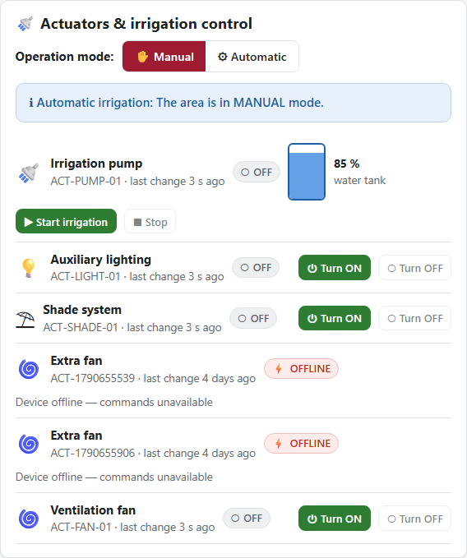
Figure US15-T6-1. Before the command: the pump is OFF. (US15-T6_Execute_Commands_Device_Simulator_1.png)
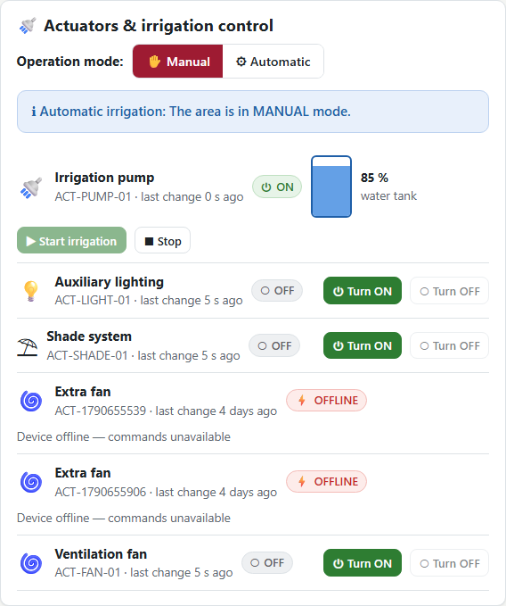
Figure US15-T6-2. 0.3 s after the command the simulator reported the pump ON. (US15-T6_Execute_Commands_Device_Simulator_2.png)
✓ Condition 2: The pump turns OFF automatically after the duration.
How it was verified: The pump turned OFF automatically 61 s after it started (duration 1 min).
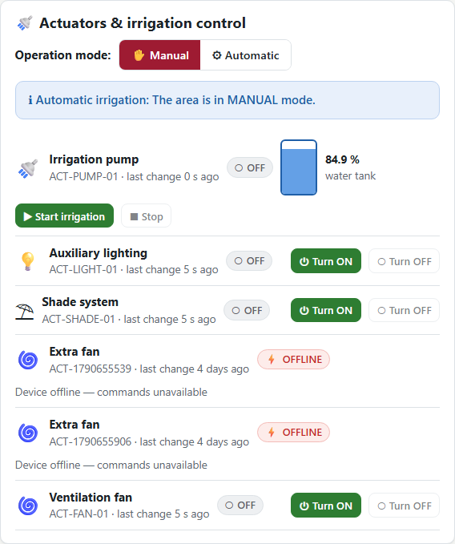
Figure US15-T6-3. After the duration (1 min) the simulator switched the pump OFF by itself. (US15-T6_Execute_Commands_Device_Simulator_3.png)
✓ Condition 3: The command is marked EXECUTED.
How it was verified: The command is marked EXECUTED (on = true).
Command lifecycle and resulting events (5 rows; US15-T6_Execute_Commands_Device_Simulator_5.csv)
kind | what | at
command | EXECUTED | 2026-09-29T04:38:52.438Z
sent | SENT | 2026-09-29T04:38:52.727Z
executed | EXECUTED | 2026-09-29T04:38:52.751Z
event | ON (MANUAL) | 2026-09-29T04:38:52.751Z
event | OFF (SYSTEM) | 2026-09-29T04:39:53.369Z
SQL: SELECT 'command' AS kind, status AS what, created_at AS at FROM actuator_commands WHERE id = $1 UNION ALL SELECT 'sent', 'SENT', sent_at FROM actuator_commands WHERE id = $1 UNION ALL SELECT 'executed', 'EXECUTED', executed_at FROM actuator_commands WHERE id = $1 UNION ALL SELECT 'event', action || ' (' || source || ')', created_at FROM actuator_events WHERE actuator_id = 'ACT-PUMP-01' AND created_at >= $2 ORDER BY at
✓ Condition 4: Evidence: Device/simulator log and actuator panel change.
How it was verified: Simulator log (poll, switch, report, auto-OFF) and the change of the actuator panel.
Simulator log (attached: US15-T6_Execute_Commands_Device_Simulator_4.log)
SmartGreenAI simulator · scenario "normal" · every 20 s · speed x1 · API http://localhost:3000/api
04:38:47 → 8/8 readings stored in 122 ms | soil 67.5/67.2 % temp 22 °C tank 85 %
04:38:52 ⏻ command cmd-1c85b0cad0bc: ACT-PUMP-01 ON for 1 min (source MANUAL)
04:39:07 → 8/8 readings stored in 141 ms | soil 68.2/67.5 % temp 21.6 °C tank 85 %
04:39:28 → 8/8 readings stored in 122 ms | soil 68.9/67.5 % temp 21.7 °C tank 84.9 %
04:39:48 → 8/8 readings stored in 104 ms | soil 69.2/67.6 % temp 21.6 °C tank 84.9 %
04:39:53 ⏹ ACT-PUMP-01 OFF (duration elapsed)
04:40:08 → 8/8 readings stored in 137 ms | soil 69.3/68.1 % temp 22 °C tank 84.9 %
=== Delivery report (US06-T5) ===
cycles: 5 · readings generated: 40 · accepted by the API: 40 · rejected: 0
success rate: 100.0 % · average round-trip: 125 ms · max: 141 ms
failed attempts: 0 · readings that went through the buffer: 0 · dropped (buffer full): 0 · still buffered: 0

iot/simulator/simulator.js — lines 261–274
async function pollCommands() {
let res;
try { res = await call('GET', '/devices/me/commands'); } catch { return; }
for (const cmd of res.commands) {
const a = actuators[cmd.actuator_id];
if (!a) continue;
a.state = cmd.action;
a.offAt = cmd.action === 'ON' && cmd.duration_min ? env.simTime + Number(cmd.duration_min) * 60000 : null;
log(`⏻ command ${cmd.id}: ${cmd.actuator_id} ${cmd.action}${cmd.duration_min ? ` for ${cmd.duration_min} min` : ''} (source ${cmd.source})`);
try { await reportState(cmd.actuator_id, cmd.action, cmd.duration_min); } catch (err) { log(`✖ state report failed: ${err.message}`); }
}
}
async function heartbeat() {

4. Attached files
- US15-T6_Execute_Commands_Device_Simulator_1.png
- US15-T6_Execute_Commands_Device_Simulator_2.png
- US15-T6_Execute_Commands_Device_Simulator_3.png
- US15-T6_Execute_Commands_Device_Simulator_4.log
- US15-T6_Execute_Commands_Device_Simulator_5.csv
- US15-T6_Execute_Commands_Device_Simulator_6.sql

5. Traceability
Related requirements | FR-16, FR-17
Implementation | commands svc collectForDevice(), reportState(), expireStale(); firmware pollCommands(), setPump(), reportState(); simulator pollCommands()
Verification | integration/commands.test.js (PENDING → SENT → EXECUTED, expiry)

6. Sign-off
Role | Name | Date | Signature
Responsible | Vicente Rocha Alfaro | October 23, 2026
Peer reviewer | Oscar Abraham Talavera Nava | October 23, 2026
Product Owner acceptance | Alexis Enrique Valle Parra | October 23, 2026
Approval record: Daily Meeting 3 of Sprint 3 (Monday, October 26, 2026), Scrum board: "Tasks moved to Done last week: US11-T3, US11-T4, US11-T5, US12-T2, US13-T3, US15-T6, US15-T7, US16-T3, US16-T4, US17-T2, US19-T4, US19-T5, US19-T6."

